A1602-ME-Sippar-Cuneiform-Clay-Tablet-2350–2150 BCE

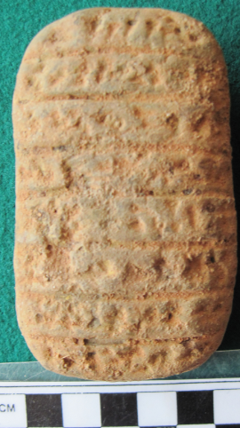 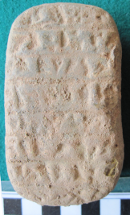

Figs. 1-2. Sippar-Cuneiform-Clay-Tablet-2350–2150 BCE

**Case No.: 3**

**Accession Number:**

**Formal Label:** Sippar-Cuneiform-Clay-Tablet-2350–2150 BCE

**Display Description:**

Sippar (Sumerian: Zimbir) was an ancient Near Eastern Sumerian and later Babylonian city on the east bank of the Euphrates river, located at the site of modern Tell Abu Habbah. On the other bank was Akkad. This cuneiform tablet is probably a business transaction detailing a prospective job and on the reverse side the final outcome.

**LC Classification:** PJ3711

**Date or Time Horizon:** 2350–2150 BCE

**Geographical Area:** Mesopotamia, probably from Sippar (modern Tell Abu Habba)

**Map:**

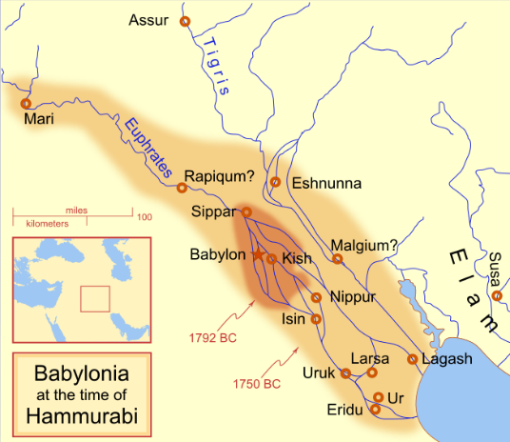

Fig. 3. Hammurabi's Babylonia, ca 1750 BCE. The river courses and coastline are those of that time period -- in general, they are not the modern rivers or coastlines. This is a Mercator projection, with north in its usual position. **From** [MapMaster](https://commons.wikimedia.org/wiki/User:MapMaster) - Own work.

**GPS Coordinates:** [33°3'32"N, 44°15'8"E](https://tools.wmflabs.org/geohack/geohack.php?params=33.058829_N_44.252153_E_globe:earth&language=en)

**Cultural Affiliation:** Sumeria

**Geographical Area: Babylonia**

**Medium:** clay

**Dimensions**: H 90.97 mm, 3.58 in  
**Weight: 174 g, 6 oz**

**Provenance: old French Collction**

**Condition:** original

**Discussion:**

**References:**

Driver, G. R. 1958. “Geographical Problems,” *Eretz Israel*: 18-20.

Leichty, Erle. 1986-1988. *Catalogue of the Babylonian Tablets in the British Museum: Tablets from Sippar 1*, vol. 6, British Museum Publications, 1986

Leichty, Erle and A. K. Grayson. 1987. *Catalogue of the Babylonian Tablets in the British Museum: Tablets from Sippar 2*, vol. 7, British Museum Publications, 1987,

Leichty, Erle *et al*. 1988. *Catalogue of the Babylonian Tablets in the British Museum: Tablets from Sippar 3*, vol. 8, British Museum Publications.

Ranke, Hermann. 1906*. Babylonian Legal and Business Documents from the Time of the First Dynasty of Babylon; Chiefly from Sippar*. Philadelphia: University of Pennsylvania.